Re: Efficacy of Intervention™ Wipes against SARS-CoV-2, the virus that causes COVID-19

To Whom It May Concern,

Virox® is pleased to announce that Intervention™ One-Step Disinfectant Cleaner & Deodorizer Wipes (Intervention) has received an EPA-approved label claim for use against SARS-CoV-2, the virus that causes COVID-19. The product has been validated by independent testing and proven efficacious against SARS-CoV-2, following a contact time of one minute. Intervention also appears on the EPA’s List N, which identifies disinfectants that are appropriate for use against SARS-CoV-2, the virus that causes COVID-19 – this can be found by searching by the product’s EPA registration number (74559-10). Intervention is expected to be effective against all variants of the virus, including SARS-CoV-2 – Delta Strain, when used in accordance with the directions for use against SARS-CoV-2.

As industry leaders in infection prevention, our mission is to ensure that our customers are protected against the threat of emerging disease outbreaks in all the markets we serve. The recent testing and addition of a SARS-CoV-2 claim to the Intervention label provides confidence that the product is highly effective in preventing the spread of the virus that causes COVID-19 when used according to label instructions.

Since the 2003 SARS outbreak in North America, Virox has been at the forefront in the fight against infectious disease outbreaks. With an initial focus in human healthcare, Virox has brought safer, more environmentally responsible disinfectants into a wide range of other industries, including animal health, dental, professional beauty, mold remediation and beyond. In addition to developing innovative disinfectant technologies, we are equally committed to providing education and technical support to help facilities optimize their infection prevention protocols.

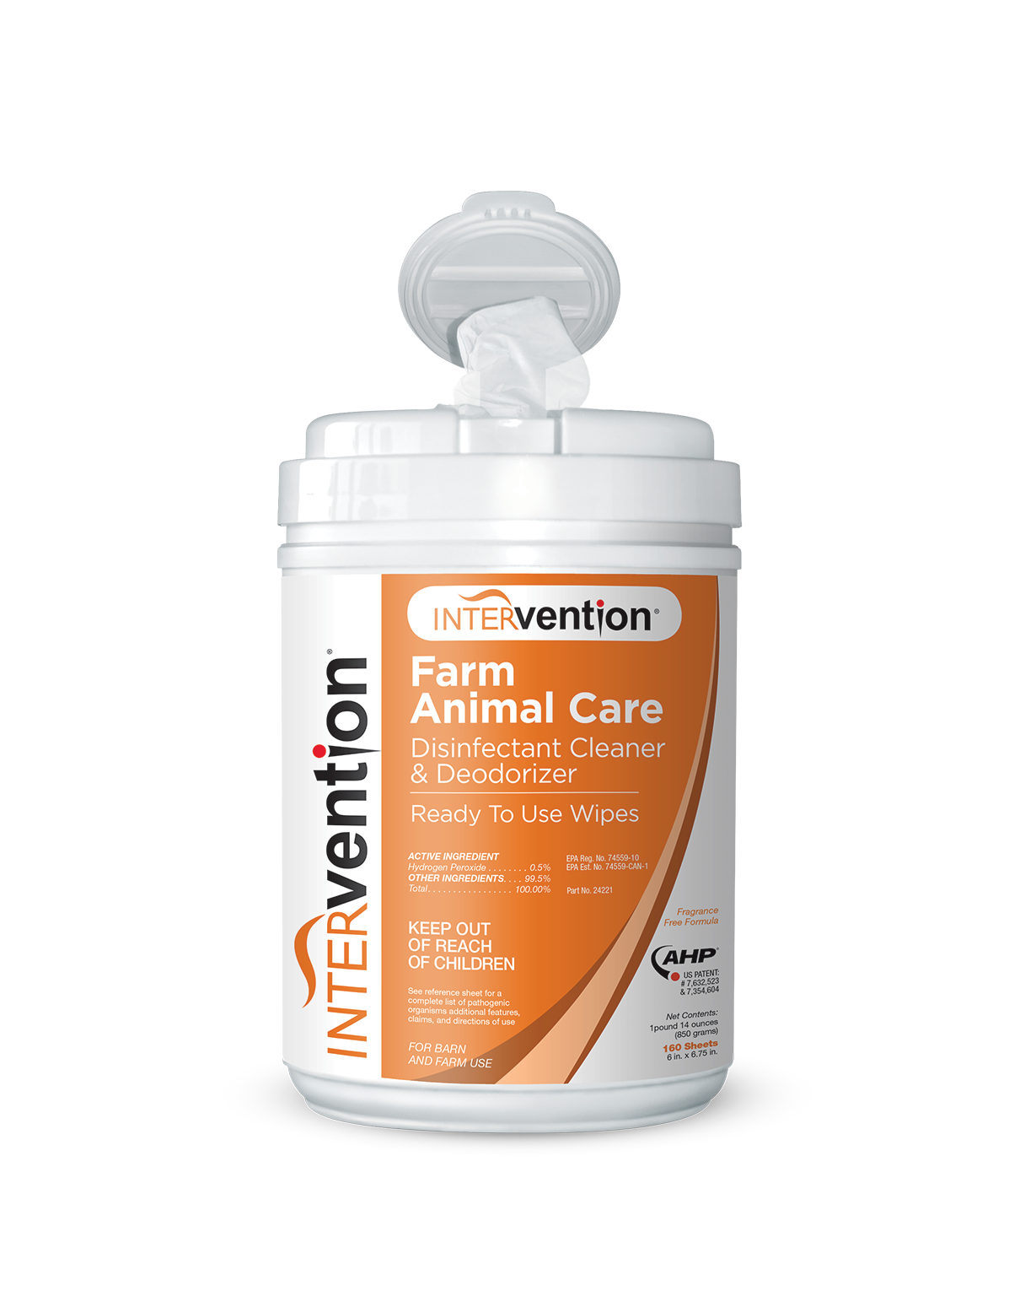
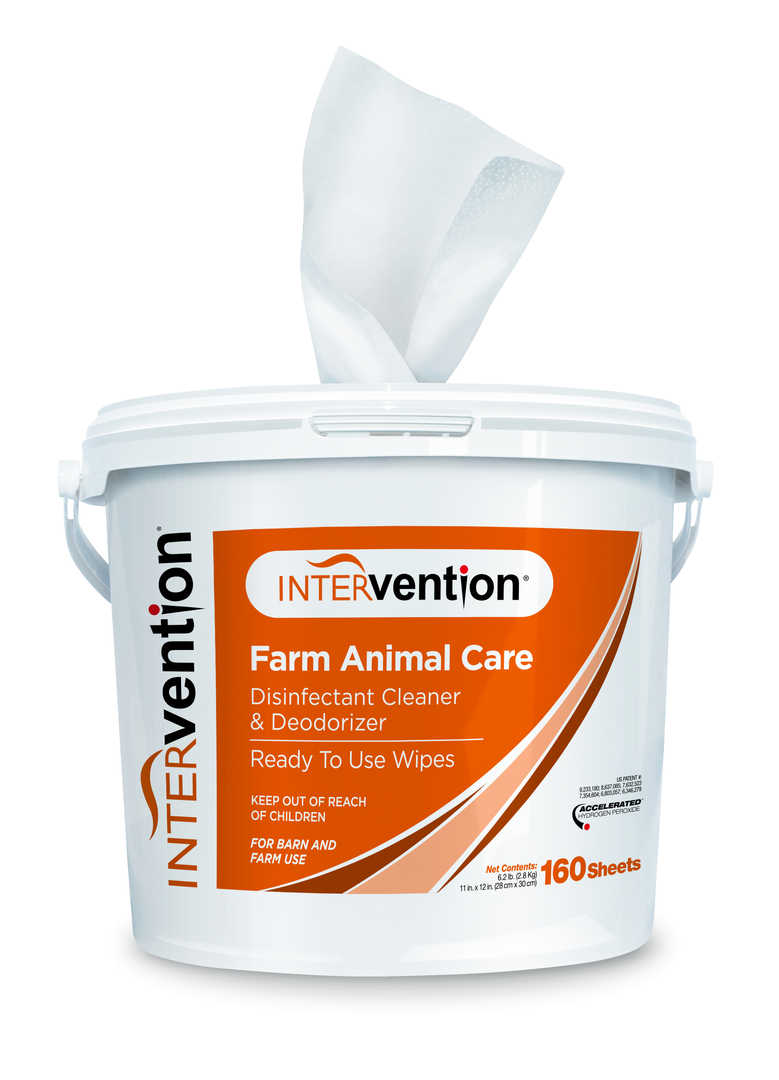
Please visit our dedicated emerging pathogens resource page (viroxfarmanimal.com/resources/emerging-pathogens) to learn more about how we can help you protect your facility against the threat of COVID-19.

Source: Virox® Technologies Inc.

For further information:
Jackie Harris
Executive Director, Marketing and Customer Success
1-800-387-7578
jharris@virox.com

